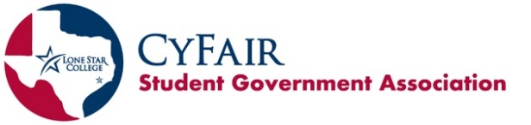
SGA General Assembly Meeting Minutes
November 21, 2024

- Call to Order
Meeting was called to order at 3:40pm.

II. Opening Roll Call
• RSO Representatives – make sure you are present for the opening/closing roll call at the beginning and end of the meeting to be counted as present.
- SGA Vice President of Records and Finances, Simran Oad, Opening Roll Call.
Tabletop, Psychology Club, Robotics, SAB, LGBTQ+, ASME, Environmental and Sustainability, Vietnamese Student Association, Math Club, Computer Science, Life First, AANHPI, K-Pop Club, Student Political Advocacy Club, Black Student Union, Phi Theta Kappa, Fashion Club, Running Club, Women’s Volleyball Club, Arab & Muslim Student Association, Business Professionals of America, Heart Towards Hope, Political Science Club, Economics Club, Billards Club.
- At-Large: None

III. Approval of Last Meeting Minutes
- Copies available when entering today’s meeting
- Link to last meeting’s minutes: https://www.lonestar.edu/student-government.htm
- Running Club moved to approve minutes. Environmental and Sustainability Club seconded. No discussion. Motion passed unanimously.

IV. Officer Reports
Executive Vice President – Emmanuel Onotota - Eonotota@my.lonestar.edu
- President, Marco Jimenez, wasn’t able to attend the meeting. Executive Vice President, Emmanuel Onotota, presided over the meeting.
- Historian position’s vacancy announcement.

Executive Vice President – Emmanuel Onotota - Eonotota@my.lonestar.edu
• Robert’s Rules of Order is used at SGA Meetings. Tips:
- Before speaking, wait to be recognized by the Chair (President)
- To be recognized, raise your hand and wait to be called on by the President
- When making a motion, say, “I move to/that…” Never say, “I motion…”
• Motions are propositions put forward by members that can be voted upon.

Vice President of Records & Finances – Simran Oad - simoad@my.lonestar.edu
• Budget Report
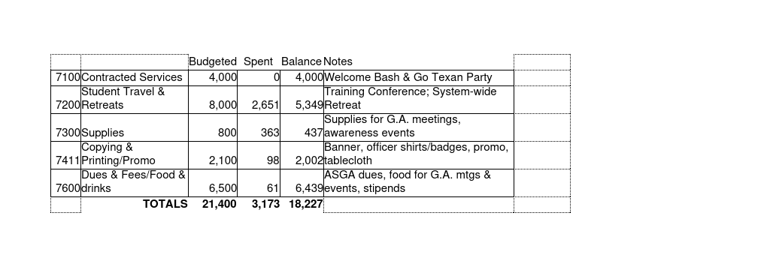
• Reminder about club announcement sheets

Vice President of Student Life – Kengeli Wiza Kamuhabwa – kkamuhabwa@my.lonestar.edu
- Upcoming Events
SAB
- Tuesday, December 3 – Movie Night: “The Grinch Who Stole Christmas” – 7pm – Cinemark Cypress
- Thursday, January 16 – Falcon Frenzy: Treat Yo’Self – 11am-12:30pm – The Nest
- Thursday, February 13 – Stuff-A-Plush – 11am-1pm – The Nest
Student Life
- Thursday, November 21 – Friendsgiving (potluck for clubs) – 6-8pm – The Nest
- Monday, December 2 – Monthly Mingle: Hot Cocoa Bar – 5:30-6:30pm – HSC 1
- Monday, December 9 – Finals Waffle Bar – 9:30-11am – The Nest
- Wednesday, January 8 – RSO Advisor/Officer Meeting – 11:30am-1pm – Falcon Room
- Monday, January 13 – Falcon Frenzy: Cocoa & Churros – 10am-12pm – The Nest
- Wednesday & Thursday, January 22 & 23 – Falcon Frenzy: Involvement Fair – 11:30am-1pm – CENT Dining Commons
- Monday, January 27 – Monthly Mingle – 5:30-6:30pm – HSC 2
- Thursday, January 30 – RSO Advisor/Officer Meeting – 11:30am-1pm – Falcon Room
- Friday, January 31 – Leadership Challenge Series – 10am-2:30pm – CASE 114-116
- Thursday, February 6 – RSO Officer Workshop: Logistics Requests – 12-1:30pm – Falcon Room
- Friday, February 7 – Bus Trip: Buffalo Soldier Museum & Soul Food Lunch
Recreational Sports
- Tuesday, January 14 – Falcon Frenzy: Salad Bar – 11am-1pm – The Nest
- Tuesday, February 4 – Big Game Pre-Party – 12-1:30pm – The Nest

Vice President of Outreach & Centers – Ahsen Ishtiaq - ahsishtiaq@my.lonestar.edu
- Upcoming Events at the Centers
- Monday–Thursday, December 2-5 – Finals Bags – All Day – Cypress Center & Westway Park Technology Center
- Wednesday, January 15 – Falcon Frenzy: What’s Poppin – 11:30am-1pm – Cypress Center
- Wednesday, January 15 – Falcon Frenzy: What’s Poppin – 5:30-6:30pm – Westway Park Technology Center
- Tuesday, February 11 – Stuff-A-Plush – 11am-1pm – Cypress Center
- Tuesday, February 11 – Stuff-A-Plush – 5:30-6:30pm – Westway Park Technology Center

Historian – vacant (Executive Vice President presented the Historian report)
• Shoutout Socials
- Follow us on Instagram at @lsccyfair_sga
- Facebook @LSCCyfairSGA
- If any RSO has posts that would want SGA to share on our social media, please send it to Lsccyfair.student.government@gmail.com. Please have the captions ready too!

Permanent Advisor - Dan Mitsven – dan.mitsven@lonestar.edu
• RSO Officers – Make sure you’re paying attention to RSO newsletters from Emily Wade. She shares lots of important information in her newsletters. If you’re not paying attention, you may miss something important!
- Friendsgiving is TONIGHT from 6-8pm in The Nest – Potluck event. Join us!
• Secondary Logos – LSC is returning to the old logo. Graphic Designer is working on re-creating logos for the clubs. Continue using current logos until this is complete. All promo item orders going forward must use the star logo.
- RSO Special Funding Requests:
- Cultural Events – Two special funding requests were approved from the last meeting. The rest of the money is still sitting there. Dan is urging RSO’s to put any special funding requests months in advance to avoid any delays. Cultural events special funding requests should also be put way in advance and avoid any late requests. Do not wait until last minute.
- Special Events/Conference/Travel

Advisor – Dallas Brown – dallas.brown@lonestar.edu
• The Nest closures:
- Friday, November 22 (for staff event)
- Thursday & Friday, December 12 & 13 (for staff events)
- December 16-January 10 (for winter break)

V. Unfinished Business
• No unfinished business

VI. New Business
• Proposed Constitution changes by Executive Council and Permanent Advisor, Dan Mitsven.
- The proposed changes/updates in the constitution were presented and explained in the meeting.
- Dan also explained how constitution changes are not put in place yet but proposed only and will be voted upon at next General Assembly meeting (February 13, 2025). The proposed updated constitution will be available on SGA’s website.
- Tabletop moved to table the motion to amend until the next General Assembly Meeting. Running Club seconded. No discussion. Motion passed unanimously.

VII. Club Announcements
• In the interest of time, please only announce special events or initiatives that would need to be known by the full group. Announcements must be concise, and you should think about the details you want to share before we get to that point in the meeting. After making your announcement, bring your sheet to the front table.
• December 6, K-Pop Club is having their next meeting – 11:00am-1:00pm at Falcon Room.
• December 3, SAB is having a Movie Night: “The Grinch Who Stole Christmas” 2000s version. Doors open at 6:00pm and close at 7:00pm. Free medium drink and popcorn will be provided. This event is strictly for current LSC-CyFair students only – 7:00pm at Cinemark Cypress 290.

VIII. Campus Issues & Shout-Outs
• At all General Assembly meetings, you will have an opportunity to share pervasive issues and shout-outs. Remember when sharing campus issues that SGA is not the “complaint department.” If you have a singular issue, you must work through appropriate channels to work through it. SGA can try to facilitate communication when there are pervasive student issues and concerns on campus or if there are unmet needs. Members are also encouraged to share shout-outs to individuals, clubs, or departments!
• Dan shouts out to Fashion club, AANHPI, VSA, AMSA, and HTH for the All Around Asia Runaway Fashion Show during the kickoff of the International Educational Week.
• Dallas shouts out the two students from LSC-CyFair who were part of the Disney Leadership Institute pilot program.
• Dan shouts out Dallas for APCA Conference 2024 and Disney Leadership Program.

IX. Closing Roll Call
• Tabletop, Tabletop, Psychology Club, Robotics, SAB, LGBTQ+, ASME, Environmental and Sustainability, Vietnamese Student Association, Math Club, Computer Science, Life First, AANHPI, K-Pop Club, Student Political Advocacy Club, Black Student Union, Phi Theta Kappa, Fashion Club, Running Club, Women’s Volleyball Club, Arab & Muslim Student Association, Business Professionals of America, Heart Towards Hope, Political Science Club, Economics Club, Billards Club.

X. Adjournment
• LGBTQ+ moved to adjourn. Running seconded. Motion passed unanimously. Meeting adjourned at 4:39pm.

Next General Assembly Meeting is Thursday, February 13, 2025.

