
SGA General Assembly Meeting Minutes
February 13, 2025

- Call to Order
Meeting was called to order at 3:36pm.

II. Opening Roll Call
• RSO Representatives – make sure you are present for the opening/closing roll call at the beginning and end of the meeting to be counted as present.
- SGA Vice President of Records and Finances, Simran Oad, Opening Roll Call.
Tabletop, Psychology Club, SAB, LGBTQ+, ASME, Environmental and Sustainability, Computer Science, AANHPI, Phi Theta Kappa, Running Club, Nigerian Student Association.
- At-Large: 6

III. Approval of Last Meeting Minutes
- Copies available when entering today’s meeting
- Link to last meeting’s minutes: https://www.lonestar.edu/student-government.htm
- Computer Science Club moved to approve minutes. Tabletop seconded. No discussion. Motion passed unanimously.

IV. Officer Reports
President – Emmanuel Onotota - Eonotota@my.lonestar.edu
- SGA Goal – A main goal is to increase SGA presence on campus.

Executive Vice President – Kenya Rowry - krowry@my.lonestar.edu
• Introduction
• Robert’s Rules of Order is used at SGA Meetings. Tips:
- Before speaking, wait to be recognized by the Chair (President)
- To be recognized, raise your hand and wait to be called on by the President
- When making a motion, say, “I move to/that…” Never say, “I motion…”
• Motions are propositions put forward by members that can be voted upon.

Vice President of Records & Finances – Simran Oad - simoad@my.lonestar.edu
• Budget Report
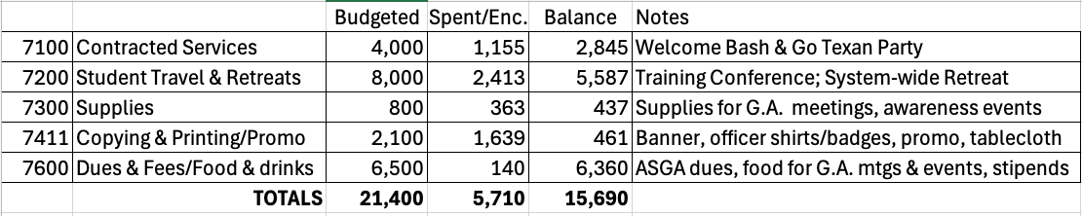
• Reminder about club announcement sheets

Vice President of Student Life – Kengeli Wiza Kamuhabwa - kkamuhabwa@my.lonestar.edu
- Upcoming Events
  - SAB
- Wednesday, February 26 – Mix & Munch Yogurt Bar – 11am-1pm – LRNC/CENT Bridge
- Tuesday, March 4 – Mardi Gras Fest – 11:30am-1:30pm – CASE Amphitheater & The Quad
- Wednesday, March 19 – Boba Bar – 11am-1pm – LRNC Coffee Shop
  - Student Life
- Friday, February 14 – Leadership Challenge Series – 10am-2:30pm – CASE 114-116
- Thursday, February 27 – Monthly Mingle (for evening students): Sausage on a Stick – 5:30-6:30pm – TECH Lobby
- Friday, February 28 – Leadership Challenge Series – 10am-2:30pm – CASE 114-116
- Wednesday, March 5 – Safe Spring Break Fanny Packs & DAAPP Interest Survey – 11am-1pm – LRNC/CENT Bridge
- Friday, March 28 – Red Carpet Gala & Casino Night – 8-11pm – The Nest
  - Recreational Sports
- Wednesday, February 19 – FALCON FAN WEEK: Women’s Volleyball vs. LSC-Montgomery – 7pm – MI3 Center (1135 Ella Crossing Dr., Houston, TX 77090)
- Friday, February 21 – FALCON FAN WEEK: Men’s Basketball vs. LSC-Montgomery – 7pm – MI3 Center
- Saturday, February 22 – FALCON FAN WEEK: Men’s Soccer vs. LSC-North Harris – Athlete Training & Health (27646 Northwest Freeway, Cypress, TX 77433)
- Saturday, February 22 – FALCON FAN WEEK: Women’s Soccer vs. LSC-North Harris – Athlete Training & Health
- Wednesday, February 26 – Women’s Volleyball vs. LSC-North Harris – 7:00pm – MI3 Center
- Friday, February 28 – Men’s Basketball vs. PVAMU – 8:30pm – PVAMU
- Monday, March 3 – 10 Tips & Tricks for Safe Spring Break – 12pm – Falcon Room
- Wednesday, March 5 – Women’s Volleyball vs. HCC – 7pm – MI3 Center
- Thursday, March 6 – Men’s Basketball vs. HCC – 8:30pm – Location TBA
- Wednesday, March 19 – Women’s Volleyball vs. Alvin C.C. – 7pm – MI3 Center

Vice President of Outreach & Centers – Ahsen Ishtiaq - ahsishtiaq@my.lonestar.edu
- Upcoming SGA Event:
  - Thursday, February 27 – Go Texan Party – 11am-1pm – CASE Amphitheater & The Quad

    - We are looking for about 14 volunteers. Most will help at tables. I will contact you once you scan the QR code or go to the link to sign up.
https://lonestarcollege.formstack.com/forms/sga_volunteer_form
- Upcoming Events at the Centers:
  - Thursday, March 6 – Safe Spring Break Fanny Packs – 11am-1pm – Cypress Center
  - Thursday, March 6– Safe Spring Break Fanny Packs – 5:30-6:30pm – Westway Park T.C.

Vice President of Communications – Carlos Trevino - ctrevino16@my.lonestar.edu
• Introduction
• Shoutout Socials
- Follow us on Instagram at @lsccyfair_sga
- Facebook @LSCCyfairSGA
- If any RSO has posts that would want SGA to share on our social media, please send it to Lsccyfair.student.government@gmail.com. Please have the captions ready too!

Permanent Advisor - Dan Mitsven
- Dan Mitsven introduced new clubs, Nigerian Student Club and Dance Team.
- RSO Forms – Dan Mitsven explained about the updated special funding forms. All forms have new updated links.
- RSO Special Funding Requests: https://www.lonestar.edu/RSO-Special-Funding-Request.htm
- Cultural Events: Dan is urging RSO’s to put any special funding requests months in advance to avoid any delays. Cultural events special funding requests should also be put way in advance and avoid any late requests. Do not wait until last minute.
- Special Events/Conference/Travel: Dan urges RSOs not to wait until the last minute to apply for special funding request as it takes time to approve. Dan Mitsven can only approve up to $1000 without SFAC’s approval.
• FY25 (this fiscal year) Budgets
  - Spending Deadline is May 15.
  - Request to Extend Past the deadline: https://www.lonestar.edu/Budget-Extension-Request-Form.htm
• RSO Budget Requests for FY26 (next year): https://www.lonestar.edu/117585
  - Due before midnight on April 15. The spending budget requests has to be specific and explained properly. The cap spending budget per club remains same at $2500.
• Student Excellence Awards: https://www.lonestar.edu/Student-Excellence-Awards-Nomination-Form.htm
  - Nominations Due Friday, April 4. Dan Mitsven explains more about Student Excellence Awards and their categories. He further urges students to provide a detailed description of why you’re nominating that club/person. Clubs can create their own awards and submit them in the forms. Do not forget the club advisors.
- Ceremony will be on Tuesday, April 29 at 6pm in the Main Stage Theater.
- Dan Mitsven announced if anyone is interested in volunteering for mascot costume at Employee Awards Ceremony.

Advisor – Dallas Brown - dallas.brown@lonestar.edu
• The Nest closures:
- Thursday, February 27 at 10:30am (Go Texan Party)
- Tuesday, March 4 at 10:30am (Mardi Gras Fest)
- Friday, March 28 (Red Carpet Gala/Vegas Night)
• Dallas announced that there are some work-study positions available for students who may be interested.

V. Unfinished Business
• Proposed Constitution Amendments
- Proposed changes/updates in the constitution were presented and explained at the November meeting.
- Per the SGA Constitution, motion was tabled until the next General Assembly.
- Proposed amendments have been available on SGA’s website since November.
- Permanent Advisor, Dan Mitsven, went over the changes. Moved by Computer Science Club, seconded by Environmental and Sustainability Club to approve amendments as presented. No discussion. Motion passed unanimously.

VI. New Business
• Approve Conditional Officers – Emmanuel Onotota yielded the chair role to VP of Records & Finances, Simran Oad, to chair the meeting during his confirmation. Conditional officers were given 1 minute to share why they are the most qualified to be confirmed for their positions.
- President – Emmanuel Onotota (move from Executive Vice President to President). Emmanuel spoke for 1 minute. After discussion, a vote was conducted. General Assembly voted to confirm Emmanuel Onotota as the new SGA President.
- Executive Vice President – Kenya Rowry spoke for 1 minute. After discussion, a vote was conducted. General Assembly voted to cofirm Kenya Rowry as the new SGA Executive Vice President.
- Vice President of Communications (title changed from Historian after the Constitutional Amendment vote) – Carlos Trevino spoke for 1 minute. General Assembly voted to confirm Carlos Trevino as the new SGA Vice President of Communications.
• RSO Special Funding Requests
- New Administrative Approvals (for information only)
  - CRU – Requested $2,500 for spring retreat – Due to timing of request, approval was needed before General Assembly. SFAC considered request and approved it at $2,300.
  - Vietnamese Student Association – Requested $2,000 for Lunar New Year event – Due to timing of request, approval was needed before General Assembly and there was insufficient time (due to holidays) for SFAC review/voting. Therefore, Dan Mitsven approved $1,000. However, the funds were not disbursed because vendor didn’t get back on time for the contract quotes.
- Computer Science Club – Requesting $1,500
  - Rock/Paper/Scissors Tournament on May 19, 20, 21, or 22
  - Plan to use their custom website to host game and track brackets. Students compete to win a club-built flagship in gaming computer. Prizes for 2nd and 3rd place winners laptop and iPad.
  - Want to hold a computer building workshop for club members to build and test the top prize.
  - Projected Budget:
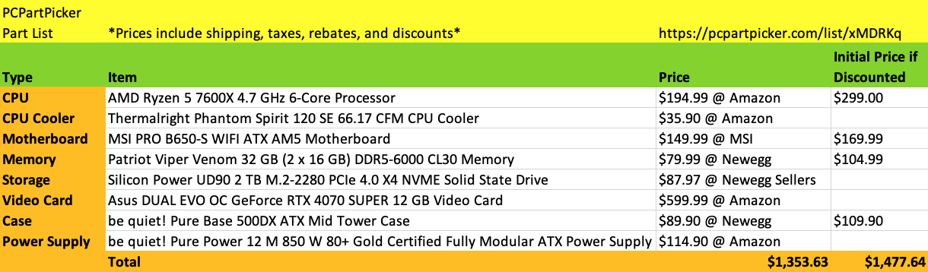
  - Permanent Advisor Dan Mitsven shared concern that these are very large prizes to be awarded by a club. He questioned whether the awarding of these large prizes will be approved by LSC purchasing processes.
  - Moved by Computer Science Club to approve. No discussion. Motion passed all in favor, but with one abstention.
- Fashion Club – Requesting $3,310
  - Dallas Fashion Week trip March 14-15
  - Due to timing of request (received 02/11/25), request has not been reviewed by the SFAC.
  - Projected Budget:
    - Van Rental $460
    - Fuel $350
    - Hotel $2,500 (6 rooms, 1 night)
  - Permanent Advisor Dan Mitsven shared that this trip may be unlikely to occur, as the deadline to submit travel paperwork is the day after this business meeting, and the club has not secured 2 employees to drive rental vans.
  - Moved by Male Empowerment Network to approve. No discussion. Motion passed unanimously.
• SFAC Member Election (nominations & voting)
- 2 student vacancies. Dan Mitsven explained what it takes to become a SFAC member.
- Amara Nwafor from Nigerian Student Association nominated herself.
- Ke’Ryan Russell from Male Empowerment Network nominated himself.
- Since there were no other candidates, it was moved and seconded to approve by acclamation. No discussion. Motion passed by majority in favor with one nay.

VII. Club Announcements
• In the interest of time, please only announce special events or initiatives that would need to be known by the full group. Announcements must be concise, and you should think about the details you want to share before we get to that point in the meeting. After making your announcement, bring your sheet to the front table.
- Tuesday, February 18th, Life First Cyfair has a flower giveaway event at 1:30pm-3:00pm in the NEST.
- Tuesday February 25th, Life First Cyfair collaborates with CRU for fun games and snacks event at 1:30pm-3:00pm in the NEST.
- Wednesday February 26th, SAB is going to have a reach out table where other students/RSOs can come and visit SAB and learn about of who they are. They will also have a yogurt bar where you can create your own bowl of yogurt with toppings while you learn about SAB at 11:00am-1:00pm in the LRNC/CENT.

VIII. Campus Issues & Shout-Outs
• At all General Assembly meetings, you will have an opportunity to share pervasive issues and shout-outs. Remember when sharing campus issues that SGA is not the “complaint department.” If you have a singular issue, you must work through appropriate channels to work through it. SGA can try to facilitate communication when there are pervasive student issues and concerns on campus or if there are unmet needs. Members are also encouraged to share shout-outs to individuals, clubs, or departments!
• Environmental and Sustainability Club and science faculty have raised the concerns over the condition of the campus pond. On the advice of Dr. Morgan, they did like to get the pond tested for eutrophication, and upon verification, they will discuss the possibility of reducing the use of fertilizers/pesticides.
• Dallas shouts out Vietnamese Student Association for the Lunar New Year celebrations.
• Dallas shouts out SAB for Stuff-A-Plush event.

IX. Closing Roll Call
• Tabletop, Psychology Club, SAB, LGBTQ+, ASME, Environmental and Sustainability, Computer Science, AANHPI, Phi Theta Kappa, Running Club, Nigerian Student Association, Life First Cyfair, Robotics Club, Political Science Club, Male Empowerment Network.

X. Adjournment
• Tabletop moved to adjourn. ASME seconded. Motion passed unanimously. Meeting adjourned at 5:03pm.

Next General Assembly Meeting is Thursday, March 20 in CASE 114-116.

