Analytics & Institutional Research (AIR)

**User Guide**

**Table of Contents**

AIR Services at a Glance 3

Analytics / Institutional Research 3

Texas State Reporting (TSR) 3

Non-AIR Services 3

AIR Report/ Data Request 4

Overview 4

How Long Will My Request Take? 4

What You Can Expect 4

AIR Resources 5

Where can I find…? 5

External Data Resources 6

THECB (Texas Higher Education Coordinating Board) 6

TEA (Texas Education Agency) 6

IPEDS 6

TACC (Texas Association of Community Colleges) 6

TxCrews 6

Quicklinks 7

Analytics and Institutional Research (AIR) Website (Public) 7

AIR Portal 7

Discovery 7

Service Center 7

Employee Intranet (SharePoint) 7

Public Records Requests (LSC-OGAC) 7

# AIR Services at a Glance

Office of Technology Services’ Analytics and Institutional Research (AIR) is the arm of the Office of Technology Services (OTS) whose mission is to serve as a trusted partner providing data and analytical expertise to support planning and decision-making.

AIR services include extraction, aggregation, analysis, interpretation, and delivery of Lone Star College data to assist decision-makers' strategic planning and initiatives.

## Analytics / Institutional Research

* Dashboards and data visualization of extensive and varied data
* Self-service data solutions in SSRS and Power BI
* Predictive modeling
* Consultation and development of abstract data models
* Training on AIR services, tools, and resources including Power BI
* Student data and statistics
* Credit and Non-Credit student enrollment data
* In consultation, clients receive:
  + Data or report in an appropriate format for the request
  + Insights or Executive Summary upon request
  + Notification of delivery or deployment

## Texas State Reporting (TSR)

Focuses on providing institutional data to external entities in compliance with various state and federal requirements.

## Non-AIR Services

* Survey creation or other forms to be completed
* PowerPoint Presentation creation or revision
* Data entry on external forms or websites
* Development and modification of Query Viewer queries in iSTAR
* Oversight of business processes related to data ingest, accuracy, storage, or integrity
* Subject Matter Expertise (Human Resources, Financial Aid, Administration and Finance, iStar, Student Records and Enrollment Services, Faulty/Staff Demographics, Employee Status, Employee Pay, Budget, etc.)
* Institutional Effectiveness - lonestar.compliance-assist.com
* Organizational Development - lonestar.edu/organizationaldevelopment.htm
* Public Records requests - External institutions may request data by submitting a request through the Public Records Department [PublicRecords@lonestar.edu](mailto:PublicRecords@lonestar.edu) or <http://www.lonestar.edu/publicrecords.htm>

# AIR Report/ Data Request

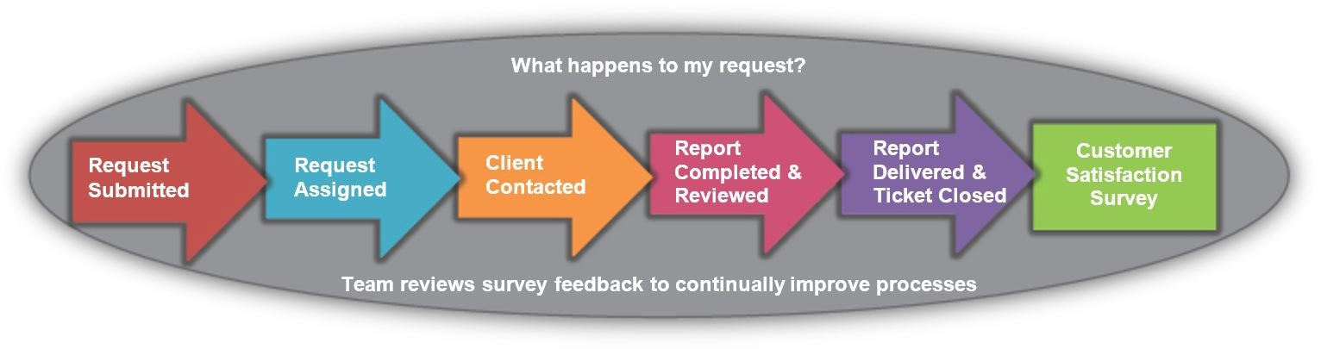

## Overview

1. Client submits an online request via Service Center at [lonestar.service-now.com.](https://lonestar.service-now.com/sp?id=sc_home&sc_catalog=71ef869913992e4045f97e776144b012)
2. The request is received by AIR.
3. AIR leadership reviews the request to determine if the data is readily available, its feasibility, overall complexity, and current priority.
4. If necessary, the ticket is assigned to AIR staff.
5. AIR contacts the client to review the details of the request and determine the due date.
6. AIR completes the request for the client and submits it for internal review.
7. Following quality control review, the report is delivered in the requested format to the client, and the ticket is closed.
8. The client receives an online survey to evaluate AIR’s services.

## How Long Will My Request Take?

|  |  |
| --- | --- |
|  | *The time to complete a data request depends on various factors including the number of data points requested,  the complexity to combine various data elements, when additional information or coordination is needed, and our current workload.* |

## What You Can Expect

* Timely communication regarding the status of your request
* Accurate data and clear explanation of how data are derived.
* Help in understanding the data provided.
* Notification of delivery or deployment

# AIR Resources

## Where can I find…?

You need information but are not sure where to go. Is that on the AIR website? Internet or Intranet?

Below is a quick guide to the information available on AIR’s various sites. AIR Analysts can also guide you through our many resources.

|  |  |
| --- | --- |
| **AIR Website (public)**  [LoneStar.edu/AIR](https://www,LoneStar.edu/AIR)   * Fast Facts * Day 1 Reports * Official Day Reports * Links to other resources | **AIR Service Center (LSC)**  [Lonestar.service-now.com](https://www.Lonestar.service-now.com)   * Report or Project Requests * Training Videos * Access Requests (Dashboard, Power BI License, Civitas) |
| **Discovery (internal)**  [Discovery.lonestar.edu](https://Discovery.lonestar.edu)  Power BI   * Completion  & Success * Graduates * Persistence | **AIR Portal (internal)**  [air.lonestar.edu](https://air.lonestar.edu)   * Credit Enrollment * Non-Credit Enrollment * Strategic Planning KPIs * Paid/Unpaid * Contact Lists |
| **Employee Intranet (SharePoint)**   | |

# External Data Resources

## THECB (Texas Higher Education Coordinating Board)

<https://www.highered.texas.gov/>

* Data Bridge: Interactive Texas Higher Education Data
* Texas Higher Education Accountability System
* Texas Higher Education Almanac
* CIP Codes
* List of Institutions
* Course Inventory
* Credentials of Value
* Student Debt
* And much more

## TEA (Texas Education Agency)

[<https://tea.texas.gov/>](https://tea.texas.gov/)

* AEIS (Academic Excellence Indicator System) – The AEIS pulls together a wide range of information on students' performance in each school and district in Texas
* District Reports, Campus Reports, P-16
* Snapshot-School District Profiles – Find statistics such as ethnicities, drop-out rates, special needs, and economically disadvantaged

## IPEDS

[[<https://nces.ed.gov/ipeds/>](https://nces.ed.gov/ipeds/)](https://nces.ed.gov/ipeds/)

* College Navigator – Find and compare general information for U.S. colleges and universities. IPEDS Data Center – Look up and compare institutions by one or more variables.
* Executive Peer Tool – Create comparisons between a focus institution and peer institutions using the data available in the printed IPEDS Data Feedback Report and additional variables from the latest collection year.

## TACC (Texas Association of Community Colleges)

[<https://www.tacc.org/>](https://www.tacc.org/)

Large resource library

## TxCrews

<https://txcrews.org/>

Texas CREWS interactive dashboards help you compare Texas public universities, public colleges, majors and career schools based on graduate wages, student loan levels, graduation rates and more.

# Quicklinks

Analytics and Institutional Research (AIR) Website (Public)  
[**www.lonestar.edu/air**](http://www.lonestar.edu/air)

AIR Portal  
[**air.lonestar.edu**](https://air.lonestar.edu/analytics/saw.dll?BIEEHome&amp%3BstartPage=1)

Discovery  
[**discovery.lonestar.edu**](https://login.microsoftonline.com/common/oauth2/authorize?client_id=871c010f-5e61-4fb1-83ac-98610a7e9110&response_mode=form_post&response_type=code%2Bid_token&scope=openid%2Bprofile&state=OpenIdConnect.AuthenticationProperties%3dsC2JhoPSVym6WCk7X6vt0mK8bU02f5g)

Service Center  
[**lonestar.service-now.com**](https://lonestar.service-now.com/sp?id=sc_home&sc_catalog=71ef869913992e4045f97e776144b012)

Employee Intranet (SharePoint)  
[**mylonestar.sharepoint.com/sites/AIR**](https://mylonestar.sharepoint.com/sites/AIR)

Public Records Requests (LSC-OGAC)  
[**lonestar.edu/public-records.htm**](http://www.lonestar.edu/public-records.htm)