## PART I - Course Information

**Course Type**

|  |  |
| --- | --- |
|  | Add Course to 060 American History and 090 Component Area Option |
|  | Add Course to 090 Component Area Option ONLY |

|  |  |
| --- | --- |
| Course Subject/Rubric (Example: HIST): | Click or tap here to enter text. |
| Number: | Click or tap here to enter text. |
| Course Title: | Click or tap here to enter text. |
| Course Catalog Description: (for existing courses - copy and paste from [online catalog](https://www.lonestar.edu/catalog/#/courses)) | Click or tap here to enter text. |
| Course Prerequisites: | Click or tap here to enter text. |
|  |  |
| The person designated as the contact must be prepared to facilitate a quick response from the curriculum team when feedback is shared by the Academic Core Curriculum Committee. | |
| Curriculum Team: | Click or tap here to enter text. |
| Contact Person: | Click or tap here to enter text. |
| Email Address: | Click or tap here to enter text. |
| Phone Number: | Click or tap here to enter text. |
| Curriculum Team Dean Facilitator: | Click or tap here to enter text. |

Include annotated sample syllabus for proposed course that clearly identifies how the course objectives are supported with this completed application.

**EMAIL THIS CORE CURRICULUM APPLICATION AND SAMPLE SYLLABUS TO:**

[Academic.affairs@lonestar.edu](mailto:Academic.affairs@lonestar.edu)

## PART II – General Education Vision Statement

*The Lone Star College general education curriculum is designed to empower students with foundational knowledge and transferrable skills guided and informed by a strong sense of values, ethics, and civic engagement. The general education curriculum prepares students for academic excellence and careers through progressively higher‐level studies in the areas of critical thinking, communication, empirical and quantitative skills, teamwork, personal responsibility, and social responsibility.*

*Embedded in the Lone Star College Core Curriculum is our firm belief that educated members of society must possess a broad base of experience and general knowledge to balance the narrow focus of degree and vocational requirements. We strive to ensure that our core curriculum provides many important benefits that exceed those listed above. Students taking the core curriculum interact with a wide range of cultures, both domestic and international. They develop important individual traits and skills such as empathy and communication that are critical for their future careers and personal development.*

*Students hone interpersonal skills and develop critical workplace and academic skills, such as communication, time management, and leadership that will enhance their ability to collaborate with colleagues, employers, and society.*

*Lone Star College values civic engagement and encourages students to become informed participants in the civic and social responsibilities of our local, state, national, and global communities. Participation in our core curriculum creates opportunities and encourages our students to evaluate their own value systems through the study of the humanities and sciences while recognizing the diversity of beliefs and values present within our society.*

*In sum, our graduates learn to become autonomous decision makers through the development of a broad base of knowledge, skills, personal wellness, and interpersonal competencies.*

|  |  |  |
| --- | --- | --- |
| 1. Please provide a summary of the proposed course and the reasons to include in the Core Curriculum. | | |
|  | Click or tap here to enter text. | |
| 1. In one paragraph, describe how the proposed course will support the LSC General Education Vision Statement. | | |
|  | Click or tap here to enter text. | |
| 1. If the curriculum team has previously proposed that this course be included in the core and it was not approved, please explain with examples why it was not approved and what changes have been made since then (if any). Indicated N/A if not applicable.   Click or tap here to enter text.   1. If this course has never been part of the core curriculum, explain why it is being proposed now for the first time. Indicate N/A if not applicable. | | | |
|  | | Click or tap here to enter text. | |
| 1. Please write here anything additional you wish the committee members and other moderators to consider. | | | |
|  | | Click or tap here to enter text. | |

## PART III – Table of Foundational Component Areas [https://reportcenter.highered.texas.gov/agency-publication/miscellaneous/elements-of-the-texas-core-curriculum/#page=7](https://reportcenter.highered.texas.gov/agency-publication/miscellaneous/elements-of-the-texas-core-curriculum/%23page=7%20%20%20)

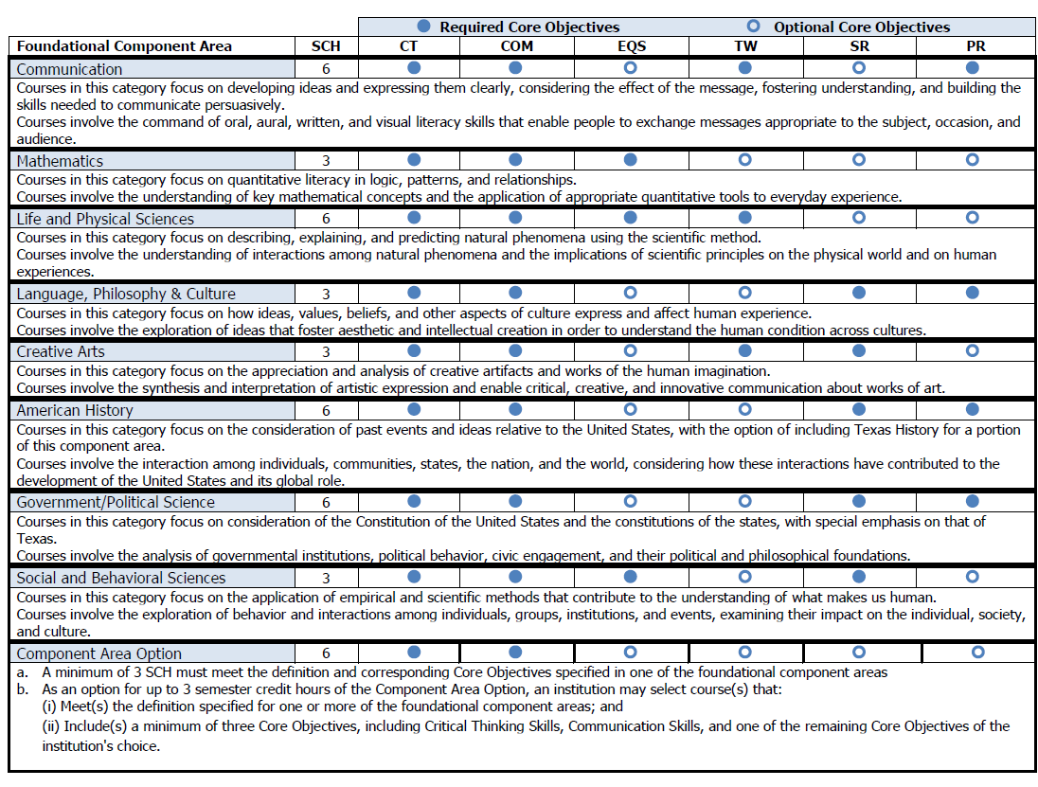

**Foundational Component Area (FCA) Descriptions:***(All answers must be documented in the sample syllabus attached to this application.)*

1. Courses in this category focus on the consideration of past events and ideas relative to the United States, with the option of including Texas History for a portion of this component area.
2. Courses in this category involve the interaction among individuals, communities, states, the nation, and the world, considering how these interactions have contributed to the development of the United States and its global role.

See: Table of Foundational Component Areas

|  |  |
| --- | --- |
| FCA Description 1: | Describe how the course will focus on the consideration of past events and ideas relative to the United States, with the option of including Texas History for a portion of this component area. |
| Response: | Click or tap here to enter text. |
|  |  |
| FCA Description 2: | Describe how the course will involve the interaction among individuals, communities, states, the nation, and the world, considering how these interactions have contributed to the development of the United States and its global role. |
| Response: | Click or tap here to enter text. |

## PART IV – Aligning Student Learning Outcomes to Foundational Component Area Descriptions

Insert the student learning outcome(s) (SLO) (e.g., Students completing the course will be able to…) that support the foundational component area (FCA) description shown on the previous page. Each outcome must be documented in the sample syllabus to be attached to this application.

Note: Use of all SLOs of the course is not required to address all the FCA descriptions, but all FCA descriptions must be addressed by an SLO of the course.

See: Table of Foundational Component Areas

|  |  |
| --- | --- |
| SLO *Enter SLO #*: | Enter SLO |
| How does this SLO align with the FCA description? | Click or tap here to enter text. |
| SLO *Enter SLO #*: | Enter SLO |
| How does this SLO align with the FCA description? | Click or tap here to enter text. |
| SLO *Enter SLO #*: | Enter SLO |
| How does this SLO align with the FCA description? | Click or tap here to enter text. |
|  |  |
|  | To add additional SLOs click on last SLO above, a + will appear, 🡪  click + to add additional entries |

## PART V – THECB Core Objectives

Address each of the THECB core objectives required within the foundational component area. Explain how the core objective is addressed by the course’s student learning outcomes, agreed upon instructional strategies, or both. Assessment must include at least one direct measure. Direct measures are defined as students' demonstrations of learning. Indirect measures are defined as students' perceptions of their learning or other measures not derived directly from student work. All responses must be documented in the sample syllabus to be attached to this application.

See: Table of Foundational Component Areas

|  |  |
| --- | --- |
| REQUIRED | |
| **Critical Thinking Skills [CT]**: to include creative thinking, innovation, inquiry, and analysis, evaluation and synthesis of information | |
|  | How will the core objective be addressed by this course?  Please specify a course’s student learning outcome and/or agreed upon instructional strategy that addresses this required core objective. |
|  | Click or tap here to enter text. |
|  | How does the curriculum team propose to measure students’ achievement of this required competency in this specific course? |
|  | Click or tap here to enter text. |
| **Communication Skills [COM]**: to include effective development, interpretation and expression of ideas through written, oral and visual communication | |
|  | How will the core objective be addressed by this course?  Please specify a course’s student learning outcome and/or agreed upon instructional strategy that addresses this required core objective. |
|  | Click or tap here to enter text. |
|  | How does the curriculum team propose to measure students’ achievement of this required competency in this specific course? |
|  | Click or tap here to enter text. |
| **Personal Responsibility [PR]**: to include the ability to connect choices, actions and consequences to ethical decision‐making | |
|  | How will the core objective be addressed by this course?  Please specify a course’s student learning outcome and/or agreed upon instructional strategy that addresses this required core objective. |
|  | Click or tap here to enter text. |
|  | How does the curriculum team propose to measure students’ achievement of this required competency in this specific course? |
|  | Click or tap here to enter text. |
| **Social Responsibility [SR]**: to include intercultural competence, knowledge of civic responsibility, and the ability to engage effectively in regional, national, and global communities | |
|  | How will the core objective be addressed by this course?  Please specify a course’s student learning outcome and/or agreed upon instructional strategy that addresses this required core objective. |
|  | Click or tap here to enter text. |
|  | How does the curriculum team propose to measure students’ achievement of this required competency in this specific course? |
|  | Click or tap here to enter text. |