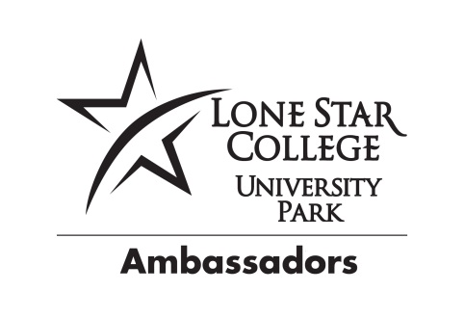

Student Ambassador
Request Form

We are excited about your interest and commitment to the student ambassadors program! To better serve you, please complete the following form when you would like the student ambassadors to attend a college or community function.

We request at least two weeks notice to prepare for your event. We will make every attempt to attend your event and we look forward to working with you!
Contact Information:
Contact Name:
Phone:
Email Address:

Event Information:
Event Name:
Event Description:
Date of Event:
Location Address: (If outside University Park Campus)
Where would you like Ambassadors to Meet you:
Event Start Time:
Event End Time:
Arrival Time/Departure time (if different then event start/end time:
-OR-
Would you like Ambassadors in shifts? If so provide hours of shifts:

Service Being Requested:
Number of Ambassadors Requested:
Please give a brief description of the role(s) the ambassadors will have in this event:

If you have any other details you would like to specify please add here:

Please return Request Form via email to Ambassador Advisor, Julie Gruber, Director of Student Services – UPark.Ambassadors@lonestar.edu

The Lone Star College System provides equal employment, admission and educational
opportunities without regard to race, color, religion, national origin, sex, age or handicap.

