Driver Background Requests (MVR) Training

Effective December, 2011, Lone Star College System (LSCS), campuses will follow a new business process for requesting and maintaining Motor Vehicle Records (MVR). The following new procedures will aid timely LSCS reporting of approved drivers as required by job positions, student and employee travel, and during the annual insurance renewal process.
In order to improve driver background procedures and eliminate issues, it is important that we be able to:
- Identify employees who are approved to drive for LSCS
- Identify specific dates of last MVR done and link approved drivers to the employee’s file, i.e., a repository of the information
- Run manual and report queries that identify employees approved to drive for LSCS (which would be available through iStar)
- Ensure that employees do not have suspensions or violations
- Maintain consistent guidelines for approval/disapproval, which are included in “Guidelines for Travel”

A Driver Record from the Texas Department of Public Safety’s Driver Records Bureau should be obtained on an annual (1 time/year) basis for all employees whose job duties include driving a System-owned and/or rental vehicle. Employees who are responsible for driving students must have an approved background within three (3) months of the travel date.
BUSINESS PROCESS:

Preparer: Send signed/scanned request form by email to supervisor for approval. Forms may be found on LSCS’ Intranet under Forms>Travel and Expense Forms>TR MVR Request to Operate Motor Vehicle
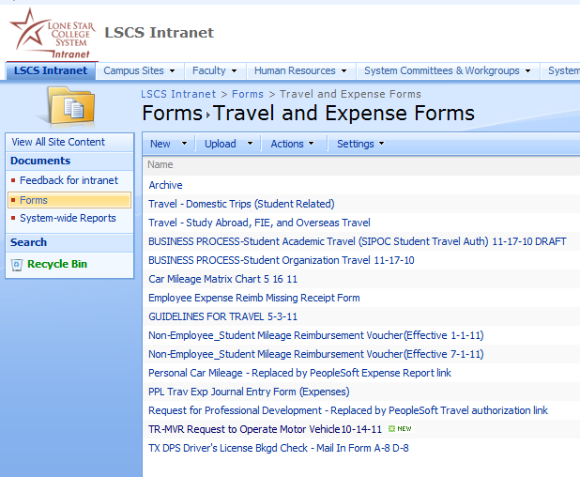

Supervisor: Once request is reviewed and approved, forward scanned form by email to campus Police Captain.

Campus Captain: Forward TR MVR Request to Operate Motor Vehicle to Dispatch Center/System Office (SO)

Police Dispatch: Run driver background and review results as applicable to LSCS guidelines. Enter driver information results into iStar’s Workforce Administration module, i.e., “approved” or not “approved”, type of driver’s license, and effective dates, etc. Notify the Captain (requestor) whether request is “clear” or “not clear”. Any questionable reports should be referred to LSCS’ Chief of Police (or delegate) for review.

Campus Captain: Notify supervisor of results.

Supervisors or department heads at campus level should maintain relevant employee driver information such as their:
- Driver Record requests
- Training or counseling the driver has received, notations regarding misconduct with the vehicle, and any reprimands concerning his/her driving, as well as positive remarks on his/her safe driving.

Any driver whose MVR results show any one of the following records is not acceptable, and should not be allowed to drive a System vehicle:
- One or more Type A violations in the last three (3) years
- Any combination of accidents and Type B violations which equal two (2) or more in the last three (3) years
- An operator’s license that has been suspended or revoked within the past three (3) years.

Violations: Type A
- Driving while intoxicated
- Driving under the influence of drugs
- Negligent homicide resulting from the use of a motor vehicle
- Operating a motor vehicle during a period of suspension or revocation of an operator’s license
- Using a motor vehicle during the commission of a felony
- Aggravated assault with a motor vehicle
- Operating a motor vehicle without the owner’s authorization
- Permitting an unlicensed person to drive
- Reckless driving
- Participation in speeding contests or illegal drag racing
- Hit and run (bodily injury and physical damage) driving
Violations: Type B
- All moving violations not listed as Type A violations

Note: Drivers using personal vehicles for System business have valid, Texas-approved automobile insurance.

