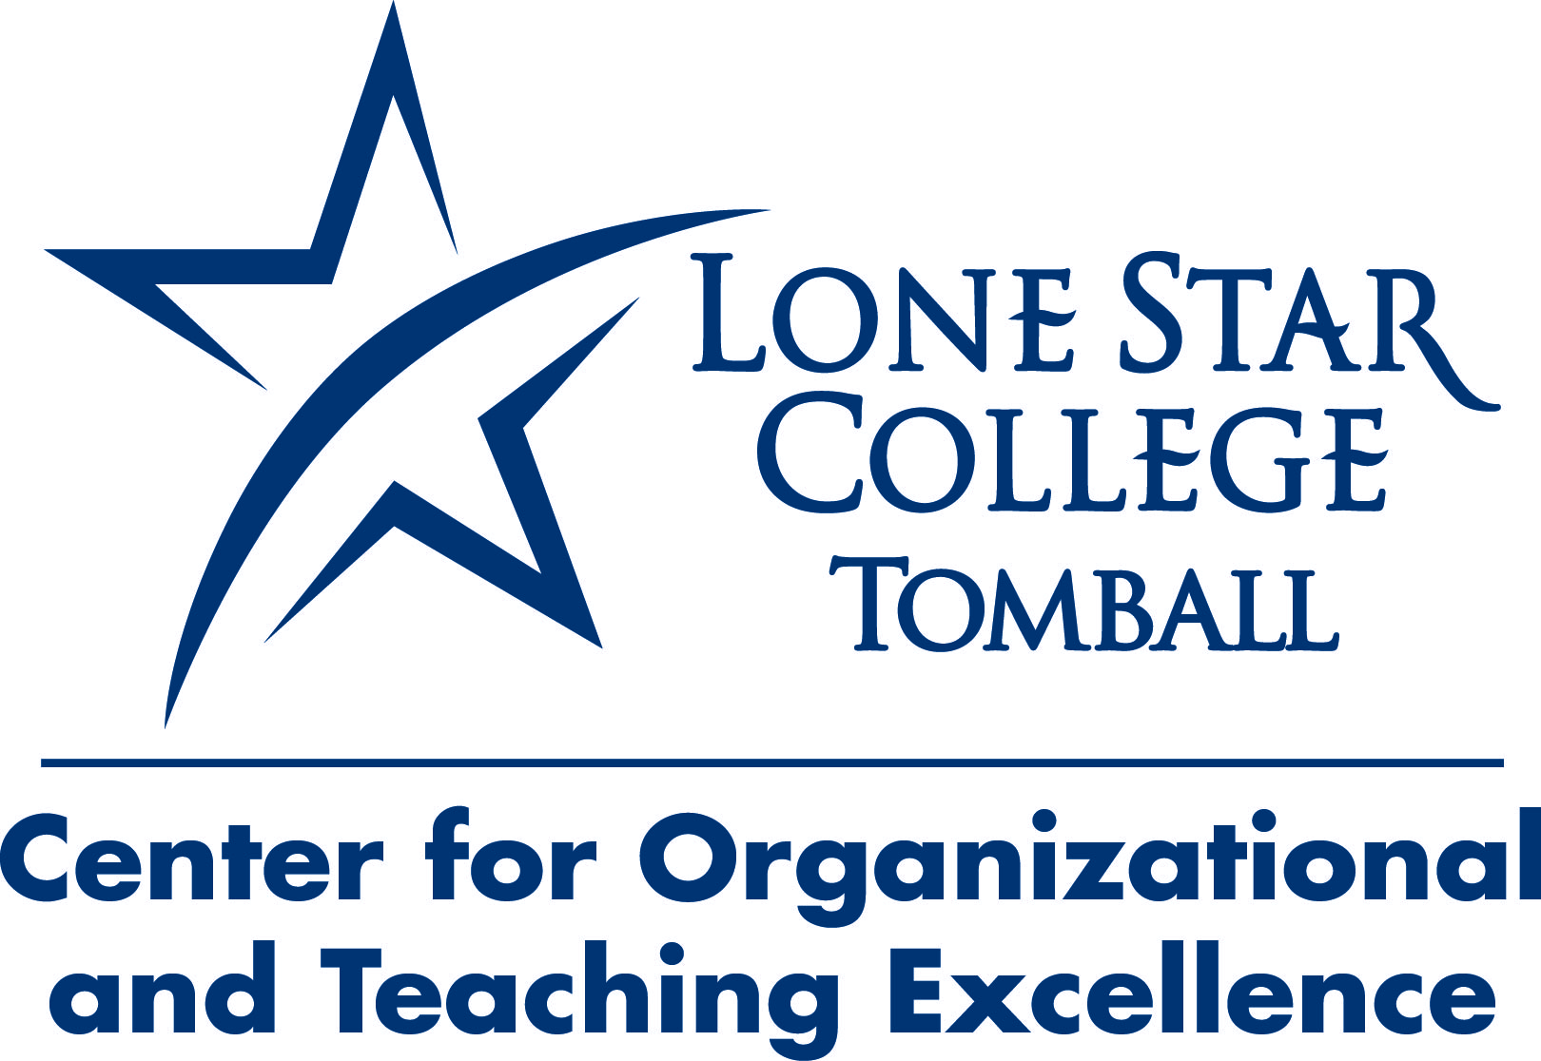

*Return the completed form to Dr. Lisa Morales in Office 219*

*by September 4.*

**Consider joining the Faculty-Staff Research Council**

The Center for Organizational and Teaching Excellence announces a new opportunity for research and scholarship at Lone Star College-Tomball: The Faculty-Staff Research Council. Members of the Faculty-Staff Research Council will

* Explore the latest research related to the College, community, and higher education trends
* Share inter-disciplinary scholarship and perspectives
* Analyze conclusions made from data
* Contribute to a new publication featuring LSC-T scholarship and analysis
* Influence the direction of the College

**Connect.*LEARN***

***Lead, Engage, Achieve, Relate, Now***

**Yes, I am interested in being a part of the culture of scholarship at Lone Star College-Tomball as a member of the Faculty-Staff Research Council! Please contact me with more information.**

**Name:**

**Department/Division:**

**Phone/email:**