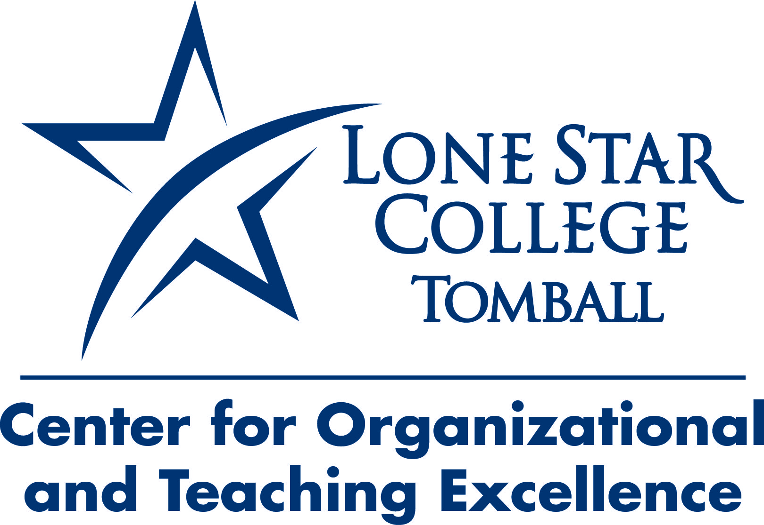
Return the completed form to Dr. Lisa Morales in Office 219
by September 4.

Attention Faculty!
Share your ideas—your research—your interests

The 2012-2013 Lone Star College-Tomball Lecture Series
Call for Presentations
The Office of Instruction is pleased to invite proposals for presentations to be offered during the inaugural year of the LSC-T Lecture Series. Hosted by the Center for Organizational and Teaching Excellence, the series will primarily feature the research and interests of College faculty and personnel. Monthly lectures are planned; these events will be free and open to public.

Yes, I am interested in presenting!

Name:

Department/Division:

Phone/Email:

Presentation Title:

Description (attach a one-page abstract of your presentation content, if you prefer):

Audio/Visual/Technology Needs:

