TEST Guidelines for CRC Math

- Please do not make changes to the content/problems on the tests. If necessary, you can make formatting changes.

- The tests will not be multiple choice. Students need to show all work and answers completely to receive full credit.

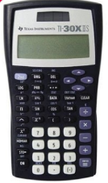
- If calculators are used, they should be scientific calculators, without the capability to simplify radicals, solve equations, etc… Recommended: TI-30X IIS

- Providing formulas on the test is optional, but it is recommended that they not be given.

- Partial credit should only be given for correct work towards solving the problem. The student should demonstrate knowledge of the concepts being tested in the question in order to earn any credit for the problem.

- Tests are designed to be completed during one class period (approximately 90 minutes). If necessary, the test can be given over two days by allowing students to fully complete part of the test each day.

- No retests, no extra credit, or additional credit for test corrections should be added to the student’s initial grade on the test.

- Reviews may be given. It is recommended that the review be an outline of concepts that will be covered on the test or practice problems from the book. The review should not be a replica of the test.

Please keep in mind that the purpose of this course is to prepare students for college level courses.

