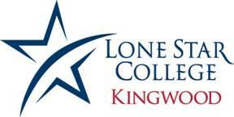

Starbursts Submission Form

Mission Statement: LSC-Kingwood literary arts seek student creative writing in poetry, fiction, nonfiction, or 6-word memoir.

For fiction, short stories should be no longer than 1,500 words. For nonfiction, narrative essays also should be no longer than 1,500 words. Please visit https://www.sixwordmemoirs.com/about/ for what a 6-word memoir is.

LSC-Kingwood visual arts seek student visual artwork in drawing, photography, painting, etc.

- One submission per LSC-Kingwood student, except students may submit up to three 6-word memoirs

- Written work should be submitted by email to lscstarbursts@gmail.com

- Visual artwork should be submitted in high resolution digital file only (300dpi) to Mari.Omori@lonestar.edu AND lscstarbursts@gmail.com

- Work will not be returned. Please make sure you have a copy for your own files

Publication Information: By submitting your work, you grant permission to Starbursts journal to publish your work in print or digital format, and reproduce and share your work with the LSC- Kingwood community and public at large. However, you retain ownership of your work.

LSC-Kingwood literary and visual arts will consider all student work for publication as long as it follows the student code of conduct (https://www.lonestar.edu/student-responsibilities.htm), and all publishing decisions by Starbursts are final.

Your Name:

Student ID Number:

Address:

Phone:

Email:

Type of submission (poem, story, essay, 6-word memoir, drawing, painting, photograph, etc.):

Title of submission (6-word memoirs don’t need a title):

